**Vagrant + Oracle Linux 7.4 + Oracle Database 18c + Create DB**

*www.bigdatalyn.com*

[*88322511@qq.com*](mailto:88322511@qq.com)

*2018/03/01*

**Oracle Linux 7.4 Install**

**Use vagrant box to install**

<http://yum.oracle.com/boxes/>

Oracle Linux 6.9 (8-FEB-2018) 367MB

Oracle Linux 7.4 (26-JAN-2018) 425MB ===========>**Download this and Use this One.**

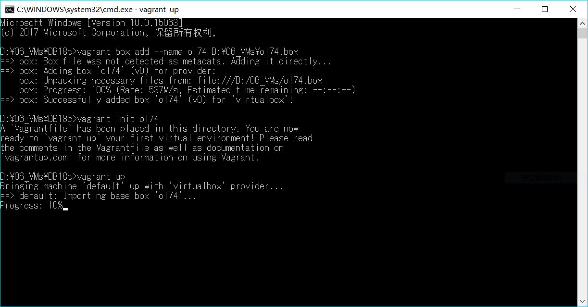

**Edit the Vagrantfile**

Sample:

#######################################################################

Vagrant.configure("2") do |config|

config.vm.box = "ol74"

config.vm.hostname = "database18c"

config.vm.provider "virtualbox" do |vb|

vb.memory = "4096"

config.vm.network :forwarded_port, guest: 1521, host: 1234

end

end

#######################################################################

**Startup Box**

vagrant up

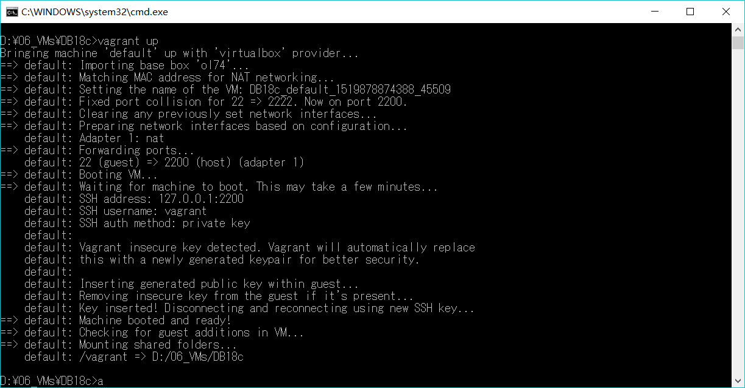

vagrant ssh-config

**Sample:**

Account: vagrnt

Private Key: D:\06_VMs\DB18c\.vagrant\machines\default\virtualbox\private_key

TCP Port: check the log(2222 or 2200)

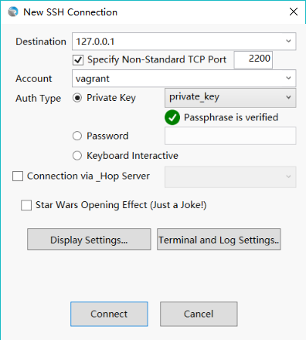

The terminal like this.

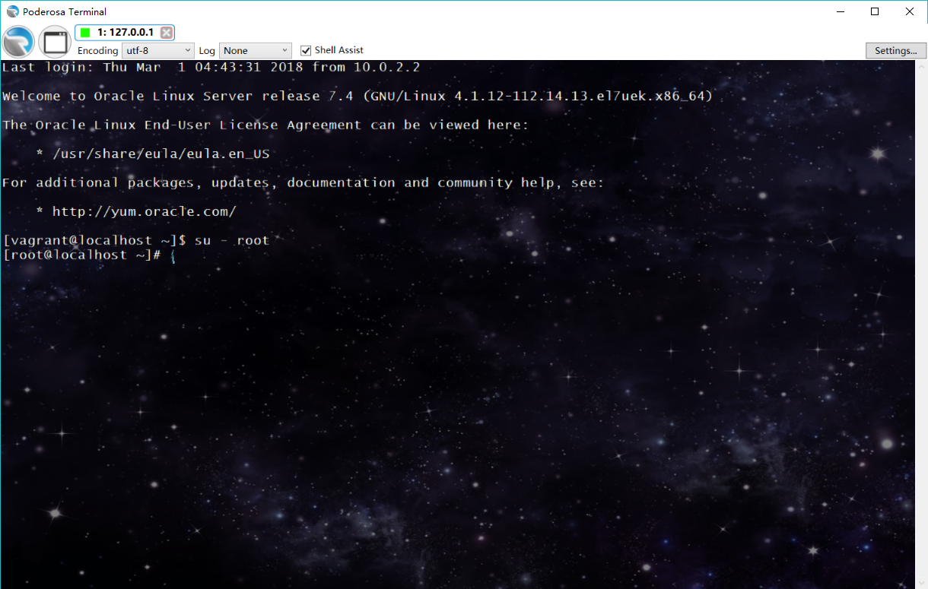

**Oracle Database 18c's Installation**

**Download**

Unitl now, regarding oracle 18c, only the exadata packages are available.

[Oracle Software Delivery Cloud](https://edelivery.oracle.com/)

Oracle Database 18.0.0.0.0

Oracle Database Client 18.0.0.0.0 (1.3 GB)

**Oracle Database (Exadata Only) 18.0.0.0.0 (3.5 GB)**

Oracle Database Grid Infrastructure 18.0.0.0.0 (3.3 GB)

The document:

*Linux Installation Guides / Database Installation Guide for Linux*

<https://docs.oracle.com/en/database/oracle/oracle-database/18/install-and-upgrade.html>

**Linux Env's setting**

Proxy

*root:(export the env if there is proxy setting in your network.)*

*export http_proxy=*[*http://xxxxxxxx:xx*](http://xxxxxxxx:xx)

*export https_proxy=*[*http://xxxxxxxx:xx*](http://xxxxxxxx:xx)

**Update package via yum**

yum list

yum -y localinstall <https://dl.fedoraproject.org/pub/epel/epel-release-latest-7.noarch.rpm>

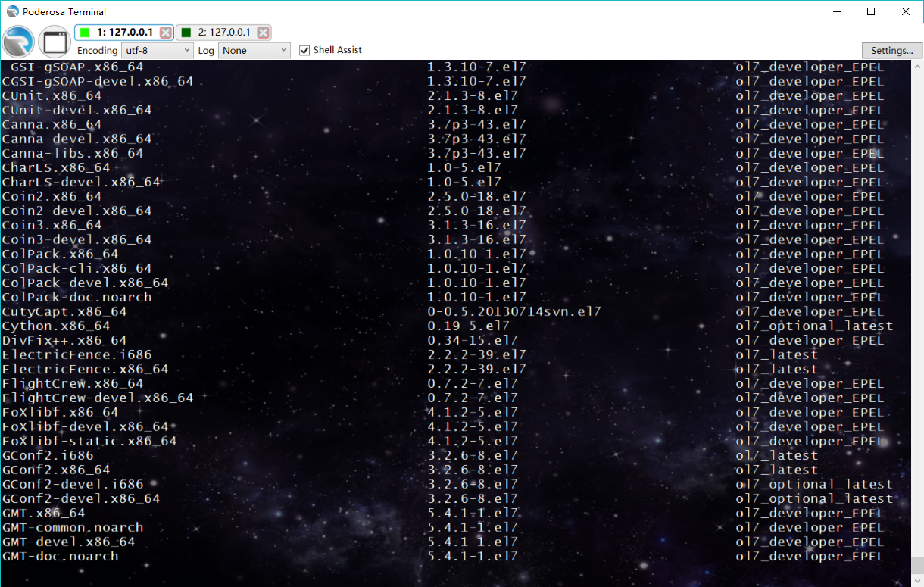

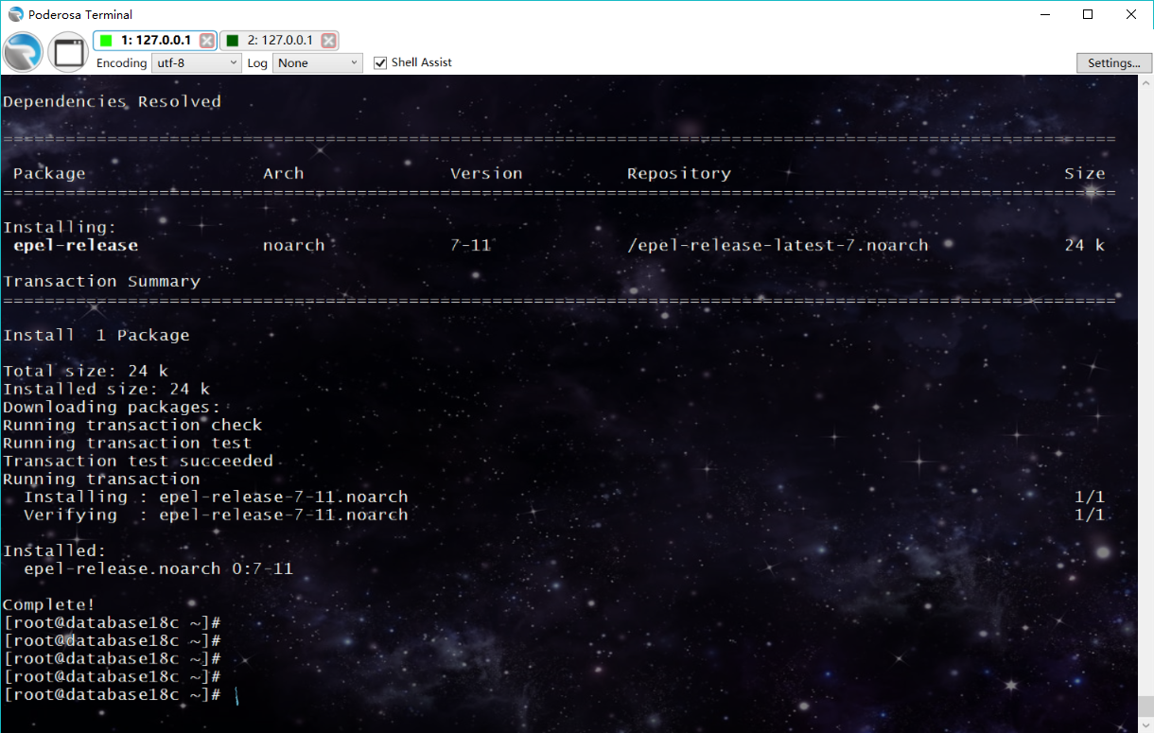

**The document:**

*Server Configuration Checklist for Oracle Database Installation*

*Installing the Oracle Preinstallation RPM From Unbreakable Linux Network*

[*https://docs.oracle.com/en/database/oracle/oracle-database/18/ladbi/installing-the-oracle-preinstallation-rpm-from-unbreakable-linux-network.html#GUID-555F704E-BD48-4E0E-AC9D-038596601194*](https://docs.oracle.com/en/database/oracle/oracle-database/18/ladbi/installing-the-oracle-preinstallation-rpm-from-unbreakable-linux-network.html#GUID-555F704E-BD48-4E0E-AC9D-038596601194)

Attention! Can NOT use the 18c's file now so we use oracle-database-server-12cR2-preinstall.x86_64

~~yum -y install oracle-database-server-18c-preinstall~~

yum install -y oracle-database-server-12cR2-preinstall.x86_64

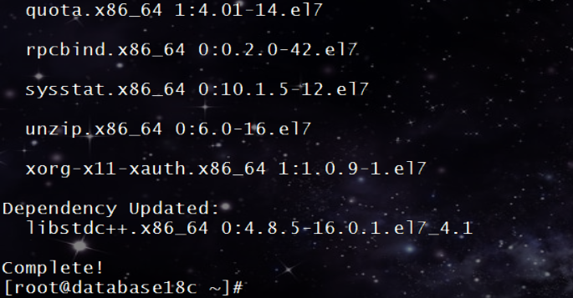

**Prepare the folder and unzip the install file to dbhome folder**

# mkdir -p /u01/app/oraInventory

# mkdir -p /u01/app/base

# mkdir -p /u01/app/oracle/product/18.0.0/dbhome_1

# chown -R oracle: /u01/app/base

# chown -R oracle: /u01/app/oraInventory

# chown -R oracle: /u01/app/oracle/product/18.0.0/dbhome_1



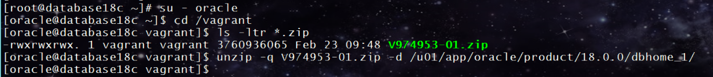

**Use db_install.rsp file to install Database 18c**

find /u01/app/oracle/product/18.0.0/dbhome_1 -name *.rsp

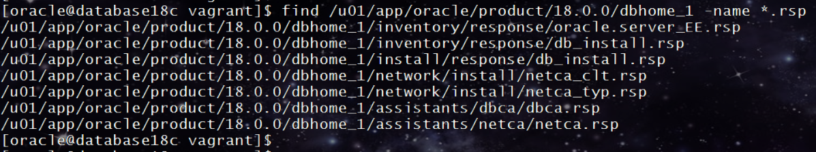

[oracle@database18c vagrant]$ cp /u01/app/oracle/product/18.0.0/dbhome_1/inventory/response/db_install.rsp /vagrant/

[oracle@database18c vagrant]$ cd /vagrant

[oracle@database18c vagrant]$ ls -ltr *.rsp

-rwxrwxrwx. 1 vagrant vagrant 17835 Mar 1 14:47 db_install.rsp

[oracle@database18c vagrant]$

[oracle@database18c vagrant]$ cat db_install.rsp | grep -v "^$" | grep -v "^#" | sort > db_install_18c.rsp

[oracle@database18c vagrant]$ vi db_install_18c.rsp

[oracle@database18c vagrant]$ cat db_install_18c.rsp | grep -v "^#" | grep -v "^$" | sort

[oracle@database18c vagrant]$

INVENTORY_LOCATION=/u01/app/oraInventory

ORACLE_BASE=/u01/app/base

ORACLE_HOME=/u01/app/oracle/product/18.0.0/dbhome_1

oracle.install.db.CLUSTER_NODES=

oracle.install.db.config.asm.ASMSNMPPassword=

oracle.install.db.config.asm.diskGroup=

oracle.install.db.config.PDBName=

oracle.install.db.config.starterdb.characterSet=

oracle.install.db.config.starterdb.emAdminPassword=

oracle.install.db.config.starterdb.emAdminUser=

oracle.install.db.config.starterdb.enableRecovery=

oracle.install.db.config.starterdb.fileSystemStorage.dataLocation=

oracle.install.db.config.starterdb.fileSystemStorage.recoveryLocation=

oracle.install.db.config.starterdb.globalDBName=

oracle.install.db.config.starterdb.installExampleSchemas=

oracle.install.db.config.starterdb.managementOption=

oracle.install.db.config.starterdb.memoryLimit=

oracle.install.db.config.starterdb.memoryOption=

oracle.install.db.config.starterdb.omsHost=

oracle.install.db.config.starterdb.omsPort=

oracle.install.db.config.starterdb.password.ALL=

oracle.install.db.config.starterdb.password.DBSNMP=

oracle.install.db.config.starterdb.password.PDBADMIN=

oracle.install.db.config.starterdb.password.SYS=

oracle.install.db.config.starterdb.password.SYSTEM=

oracle.install.db.config.starterdb.SID=

oracle.install.db.config.starterdb.storageType=

oracle.install.db.config.starterdb.type=

oracle.install.db.ConfigureAsContainerDB=

oracle.install.db.InstallEdition=EE

oracle.install.db.OSBACKUPDBA_GROUP=backupdba

oracle.install.db.OSDBA_GROUP=dba

oracle.install.db.OSDGDBA_GROUP=dgdba

oracle.install.db.OSKMDBA_GROUP=kmdba

oracle.install.db.OSOPER_GROUP=

oracle.install.db.OSRACDBA_GROUP=racdba

oracle.install.option=INSTALL_DB_SWONLY

oracle.install.responseFileVersion=/oracle/install/rspfmt_dbinstall_response_schema_v18.0.0

UNIX_GROUP_NAME=oinstall

[oracle@database18c vagrant]$ /u01/app/oracle/product/18.0.0/dbhome_1/runInstaller -silent -ignorePrereq -waitforcompletion -responseFile /vagrant/db_install_18c.rsp

[oracle@database18c vagrant]$ /u01/app/oracle/product/18.0.0/dbhome_1/runInstaller -silent -ignorePrereq -waitforcompletion -responseFile /vagrant/db_install_18c.rsp

Launching Oracle Database Setup Wizard...

[WARNING] [INS-13014] Target environment does not meet some optional requirements.

CAUSE: Some of the optional prerequisites are not met. See logs for details. installActions2018-03-01_03-26-10PM.log

ACTION: Identify the list of failed prerequisite checks from the log: installActions2018-03-01_03-26-10PM.log. Then either from the log file or from installation manual find the appropriate configuration to meet the prerequisites and fix it manually.

The response file for this session can be found at:

/u01/app/oracle/product/18.0.0/dbhome_1/install/response/db_2018-03-01_03-26-10PM.rsp

You can find the log of this install session at:

/tmp/InstallActions2018-03-01_03-26-10PM/installActions2018-03-01_03-26-10PM.log

As a root user, execute the following script(s):

1. /u01/app/oraInventory/orainstRoot.sh

2. /u01/app/oracle/product/18.0.0/dbhome_1/root.sh

Execute /u01/app/oraInventory/orainstRoot.sh on the following nodes:

[database18c]

Execute /u01/app/oracle/product/18.0.0/dbhome_1/root.sh on the following nodes:

[database18c]

Successfully Setup Software with warning(s).

Moved the install session logs to:

/u01/app/oraInventory/logs/InstallActions2018-03-01_03-26-10PM

[oracle@database18c vagrant]$

Check the error: size is zero.

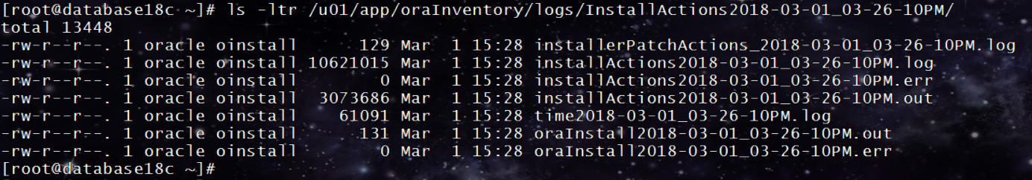

Root user execute the scripts.

/u01/app/oraInventory/orainstRoot.sh

/u01/app/oracle/product/18.0.0/dbhome_1/root.sh

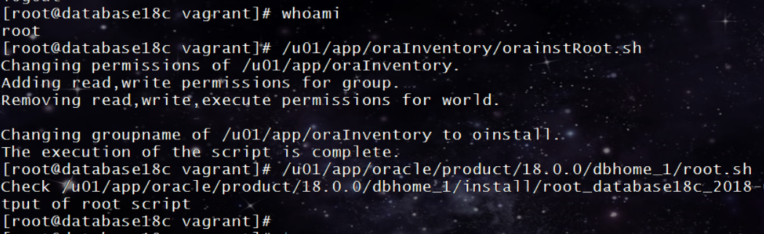

[oracle@database18c ~]$ sqlplus /nolog

SQL*Plus: Release 18.0.0.0.0 Production on Thu Mar 1 15:51:06 2018

Version 18.1.0.0.0

Copyright (c) 1982, 2017, Oracle. All rights reserved.

SQL>

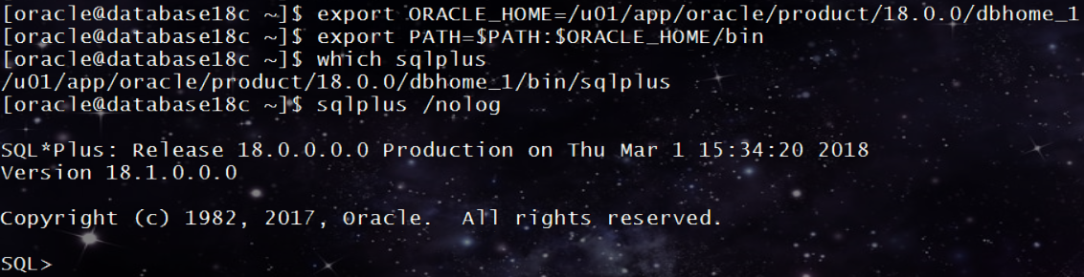

**Oracle Database 18c Create Database**

The specific methods for creating a database are:

With Database Configuration Assistant (DBCA), a graphical tool.

With the CREATE DATABASE SQL statement.

**This time, I use create database sql statement to create oracle 18c database.**

**The document:**

2.4 Creating a Database with the CREATE DATABASE Statement

<https://docs.oracle.com/en/database/oracle/oracle-database/18/admin/creating-and-configuring-an-oracle-database.html#GUID-18B03451-5C74-4B53-A892-656C3E8A2556>

**Step 0. Modify the env file.**

[oracle@database18c ~]$ cat .bashrc

# .bashrc

# Source global definitions

if [ -f /etc/bashrc ]; then

. /etc/bashrc

fi

# Uncomment the following line if you don't like systemctl's auto-paging feature:

# export SYSTEMD_PAGER=

# User specific aliases and functions

export ORACLE_BASE=/u01/app/base

export ORACLE_HOME=/u01/app/oracle/product/18.0.0/dbhome_1

export PATH=$ORACLE_HOME/bin:$ORACLE_HOME/OPatch/:/usr/sbin:/usr/local/bin:/usr/bin

export LD_LIBRARY_PATH=/u01/app/oracle/product/18.0.0/dbhome_1/lib:/lib:/usr/lib

alias sqlplus='rlwrap sqlplus'

[oracle@database18c ~]$

**Step 1. create orapwd file.**

[oracle@database18c ~]$ orapwd file='$ORACLE_HOME/dbs/orapwPRODCDB' password=oracle force=y

OPW-00029: Password complexity failed for SYS user : Password must contain at least 8 characters.

[oracle@database18c ~]$

[oracle@database18c ~]$ orapwd file='$ORACLE_HOME/dbs/orapwPRODCDB.001' password=oracle force=y format=12

[oracle@database18c ~]$ orapwd file='$ORACLE_HOME/dbs/orapwPRODCDB' input_file='$ORACLE_HOME/dbs/orapwPRODCDB.001'

[oracle@database18c ~]$

**Step 2 create init.ora file.**

[oracle@database18c ~]$ cd $ORACLE_HOME/dbs

[oracle@database18c dbs]$ ls

init.ora orapwPRODCDB orapwPRODCDB.001

[oracle@database18c dbs]$ cat init.ora | grep -v '^#' | grep -v '^$'

db_name='ORCL'

memory_target=1G

processes = 150

audit_file_dest='<ORACLE_BASE>/admin/orcl/adump'

audit_trail ='db'

db_block_size=8192

db_domain=''

db_recovery_file_dest='<ORACLE_BASE>/fast_recovery_area'

db_recovery_file_dest_size=2G

diagnostic_dest='<ORACLE_BASE>'

dispatchers='(PROTOCOL=TCP) (SERVICE=ORCLXDB)'

open_cursors=300

remote_login_passwordfile='EXCLUSIVE'

undo_tablespace='UNDOTBS1'

control_files = (ora_control1, ora_control2)

compatible ='11.2.0'

[oracle@database18c dbs]$

[oracle@database18c dbs]$ cat init.ora | grep -v '^$' | grep -v '^#' > initPRODCDB.ora

[oracle@database18c dbs]$ vi initPRODCDB.ora

[oracle@database18c dbs]$ cat initPRODCDB.ora

db_name='PRODCDB'

memory_target=800m

processes = 150

audit_file_dest='/u01/app/oracle/admin/prodcdb/adump'

audit_trail ='db'

db_block_size=8192

db_domain=''

db_recovery_file_dest='/u01/app/oracle/fast_recovery_area'

db_recovery_file_dest_size=2G

diagnostic_dest='/u01/app/oracle'

dispatchers='(PROTOCOL=TCP) (SERVICE=ORCLXDB)'

open_cursors=300

remote_login_passwordfile='EXCLUSIVE'

undo_tablespace='UNDOTBS1'

control_files = ('/u01/app/oracle/oradata/PRODCDB/ora_control01.ctl', '/u01/app/oracle/oradata/PRODCDB/ora_control02.ctl')

compatible ='18.0.0'

_exadata_feature_on=true

[oracle@database18c dbs]$

Beacuse the installfile is only use in Exadata, so we should add the following parameter in Linux env.

_exadata_feature_on=true

[root@database18c oracle]# mkdir -p /u01/app/oracle/admin/prodcdb/adump

[root@database18c oracle]# chown -R oracle: /u01/app/oracle/

[oracle@database18c ~]$ mkdir /u01/app/oracle/oradata/PRODCDB -p

[oracle@database18c ~]$ mkdir /u01/app/oracle/fast_recovery_area

[oracle@database18c ~]$

[oracle@database18c dbs]$ sqlplus / as sysdba

SQL*Plus: Release 18.0.0.0.0 Production on Thu Mar 1 16:21:00 2018

Version 18.1.0.0.0

Copyright (c) 1982, 2017, Oracle. All rights reserved.

Connected to an idle instance.

SQL> create spfile from pfile;

File created.

SQL> !ls -ltr

total 32

-rw-r--r--. 1 oracle oinstall 3079 May 14 2015 init.ora

-rw-r-----. 1 oracle oinstall 2048 Mar 1 16:04 orapwPRODCDB.001

-rw-r-----. 1 oracle oinstall 11264 Mar 1 16:05 orapwPRODCDB

-rw-rw----. 1 oracle oinstall 1544 Mar 1 16:19 hc_PRODCDB.dat

-rw-r--r--. 1 oracle oinstall 578 Mar 1 16:20 initPRODCDB.ora

-rw-r-----. 1 oracle oinstall 2560 Mar 1 16:21 spfilePRODCDB.ora

SQL>

**Step 3. Issue create database sql.**

SQL> startup nomount;

ORACLE instance started.

Total System Global Area 838856896 bytes

Fixed Size 8663232 bytes

Variable Size 562036736 bytes

Database Buffers 260046848 bytes

Redo Buffers 8110080 bytes

SQL>

SQL> host vi createdb.sql

SQL> host cat createdb.sql

CREATE DATABASE PRODCDB

USER SYS IDENTIFIED BY sys_password

USER SYSTEM IDENTIFIED BY system_password

LOGFILE GROUP 1 ('/u01/app/oracle/oradata/PRODCDB/redo01a.log','/u01/app/oracle/oradata/PRODCDB/redo01b.log')

SIZE 100M BLOCKSIZE 512,

GROUP 2 ('/u01/app/oracle/oradata/PRODCDB/redo02a.log','/u01/app/oracle/oradata/PRODCDB/redo02b.log')

SIZE 100M BLOCKSIZE 512,

GROUP 3 ('/u01/app/oracle/oradata/PRODCDB/redo03a.log','/u01/app/oracle/oradata/PRODCDB/redo03b.log')

SIZE 100M BLOCKSIZE 512

MAXLOGHISTORY 1

MAXLOGFILES 16

MAXLOGMEMBERS 3

MAXDATAFILES 1024

CHARACTER SET AL32UTF8

NATIONAL CHARACTER SET AL16UTF16

EXTENT MANAGEMENT LOCAL

DATAFILE '/u01/app/oracle/oradata/PRODCDB/system01.dbf'

SIZE 700M REUSE AUTOEXTEND ON NEXT 10240K MAXSIZE UNLIMITED

SYSAUX DATAFILE '/u01/app/oracle/oradata/PRODCDB/sysaux01.dbf'

SIZE 550M REUSE AUTOEXTEND ON NEXT 10240K MAXSIZE UNLIMITED

DEFAULT TABLESPACE deftbs

DATAFILE '/u01/app/oracle/oradata/PRODCDB/deftbs01.dbf'

SIZE 500M REUSE AUTOEXTEND ON MAXSIZE UNLIMITED

DEFAULT TEMPORARY TABLESPACE tempts1

TEMPFILE '/u01/app/oracle/oradata/PRODCDB/temp01.dbf'

SIZE 20M REUSE AUTOEXTEND ON NEXT 640K MAXSIZE UNLIMITED

UNDO TABLESPACE undotbs1

DATAFILE '/u01/app/oracle/oradata/PRODCDB/undotbs01.dbf'

SIZE 200M REUSE AUTOEXTEND ON NEXT 5120K MAXSIZE UNLIMITED

ENABLE PLUGGABLE DATABASE

SEED

FILE_NAME_CONVERT = ('/u01/app/oracle/oradata/PRODCDB/',

'/u01/app/oracle/oradata/pdbseed/')

LOCAL UNDO ON;

SQL>

SQL> host mkdir /u01/app/oracle/oradata/pdbseed

SQL>

SQL> show parameter enable_pluggable

NAME TYPE VALUE

------------------------------------ ----------- ------------------------------

enable_pluggable_database boolean FALSE

SQL> alter system set enable_pluggable_database=true;

alter system set enable_pluggable_database=true

*

ERROR at line 1:

ORA-02095: specified initialization parameter cannot be modified

SQL> alter system set enable_pluggable_database=true scope=spfile;

System altered.

SQL> shu immediate;

ORA-01507: database not mounted

ORACLE instance shut down.

SQL> startup nomount;

ORACLE instance started.

Total System Global Area 838857288 bytes

Fixed Size 8901192 bytes

Variable Size 562036736 bytes

Database Buffers 260046848 bytes

Redo Buffers 7872512 bytes

SQL> show parameter enable_pluggable

NAME TYPE VALUE

------------------------------------ ----------- ------------------------------

enable_pluggable_database boolean TRUE

SQL>

SQL> @createdb

Database created.

SQL>

**Step 4. Execute the scripts**

SQL> host vi dbv.sql

SQL> host cat dbv.sql

@?/rdbms/admin/catalog.sql
@?/rdbms/admin/catproc.sql
@?/rdbms/admin/utlrp.sql

SQL> @dbv.sql

It will take some time to execute this sql to build Data Dictionary Views.Please keep your patience.

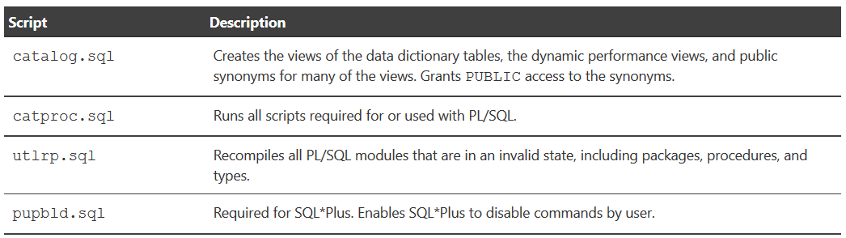

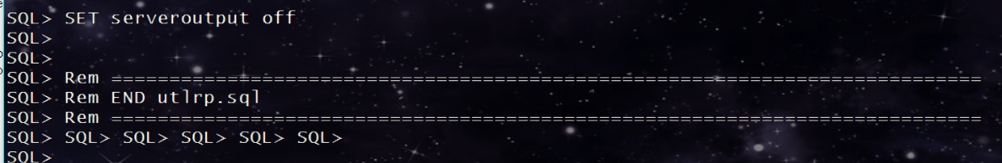

Completed!

SQL> conn system/system_password

Connected.

SQL> show user

USER is "SYSTEM"

SQL> @?/sqlplus/admin/pupbld.sql

~

SQL> Rem BEGIN SQL_FILE_METADATA

SQL> Rem SQL_SOURCE_FILE: rdbms/admin/sqlsessend.sql

SQL> Rem SQL_SHIPPED_FILE: rdbms/admin/sqlsessend.sql

SQL> Rem SQL_PHASE: SQLSESSEND

SQL> Rem SQL_STARTUP_MODE: NORMAL

SQL> Rem SQL_IGNORABLE_ERRORS: NONE

SQL> Rem END SQL_FILE_METADATA

SQL> Rem

SQL> Rem MODIFIED (MM/DD/YY)

SQL> Rem surman 03/08/13 - 16462837: Common start and end scripts

SQL> Rem surman 03/08/13 - Created

SQL> Rem

SQL>

SQL> alter session set "_ORACLE_SCRIPT" = false;

Session altered.

SQL>

**All the works are done!**

[oracle@database18c ~]$

[oracle@database18c ~]$ export ORACLE_SID=PRODCDB; sqlplus / as sysdba

SQL*Plus: Release 18.0.0.0.0 Production on Thu Mar 1 17:28:53 2018

Version 18.1.0.0.0

Copyright (c) 1982, 2017, Oracle. All rights reserved.

Connected to:

Oracle Database 18c Enterprise Edition Release 18.0.0.0.0 - Production

Version 18.1.0.0.0

SQL> select * from v$version;

BANNER

--------------------------------------------------------------------------------

BANNER_FULL

--------------------------------------------------------------------------------

BANNER_LEGACY

--------------------------------------------------------------------------------

CON_ID

----------

Oracle Database 18c Enterprise Edition Release 18.0.0.0.0 - Production

Oracle Database 18c Enterprise Edition Release 18.0.0.0.0 - Production

Version 18.1.0.0.0

Oracle Database 18c Enterprise Edition Release 18.0.0.0.0 - Production

BANNER

--------------------------------------------------------------------------------

BANNER_FULL

--------------------------------------------------------------------------------

BANNER_LEGACY

--------------------------------------------------------------------------------

CON_ID

----------

SQL> show pdbs;

CON_ID CON_NAME OPEN MODE RESTRICTED

---------- ------------------------------ ---------- ----------

2 PDB$SEED READ ONLY NO

SQL>

